Web Revitalization Program

YOUTH Services

Wireframes & Mock-ups

Contents

Youth Services Application Requirements 2

VIEWS 2

FILTERS & SEARCH 2

PDF CREATION 2

SUMMARY INFORMATION 2

DETAIL INFORMATION 3

Map 4

List 5

Details 6

# Youth Services Application Requirements

### VIEWS

* Map View of Youth Services
* List View of Youth Services
* The application should exist under 1 tab and there should be a UI control that allows the user to switch between the list and map view
* The Map View is the default/primary view

### FILTERS & SEARCH

* The filters for the Map and List should be the same and should be retained as users switch between the 2 views (i.e. if a user sets a filter while looking at the map they should be able to switch to the list view and keep the filter intact)
* **Keyword Search**: This should be a text field that will look through all fields in the result set.
* **Map Address Zoom**: The Map view should have a control which allows a user to zoom to an address of their choice. If the user is on a mobile device the map should auto-zoom to their location.
* **Audience Filter**: This should be a single-select control. This filter should be defaulted to 'Youth'. There should be an 'All' entry in the list. The other options in this list will come from Sophie and the 211 vendor.
* **Topic Filter**: This should be a single-select control. The default should be set to the 'All' option. This control should have the ability to have sub-topics (i.e. Education should be an option but there will also be some sub topics underneath education).
* **Language Filter**: This filter should be a single-select control. The default should be set to the 'All' option.
* **Ethno-Cultural Filter**: This filter should be a single-select control. The default should be set to the 'All' option.
* **Accessibility Filter**: This filter should be a check-box control. The default should be NOT selected.
* All filtering except Keyword search should be executed dynamically as the user selects items from the select and check box controls
* Filtering should work in a 'AND' fashion so users can combine filters
* Filtering should be retained in the URL (via push state logic) to enable social media sharing of filtered map and list views

### PDF CREATION

Users require the ability to generate a PDF of a filtered List View. When creating the PDF users should be able to select the records they want to include in their PDF. The default selected records should be the items that the user has currently filtered (very similar to the Progress Portal functionality).

### SUMMARY INFORMATION

The map info-box and the list summary should include the following fields:

* Name of Organization (hyperlinked to the detail view)
* Address
* Phone Number
* Website
* Topic
* Eligibility Details
* Accessibility (icon with full accessibility text display on hover)

### DETAIL INFORMATION

The detail page should include all information returned in the 211 API Call for the organization.

# Map

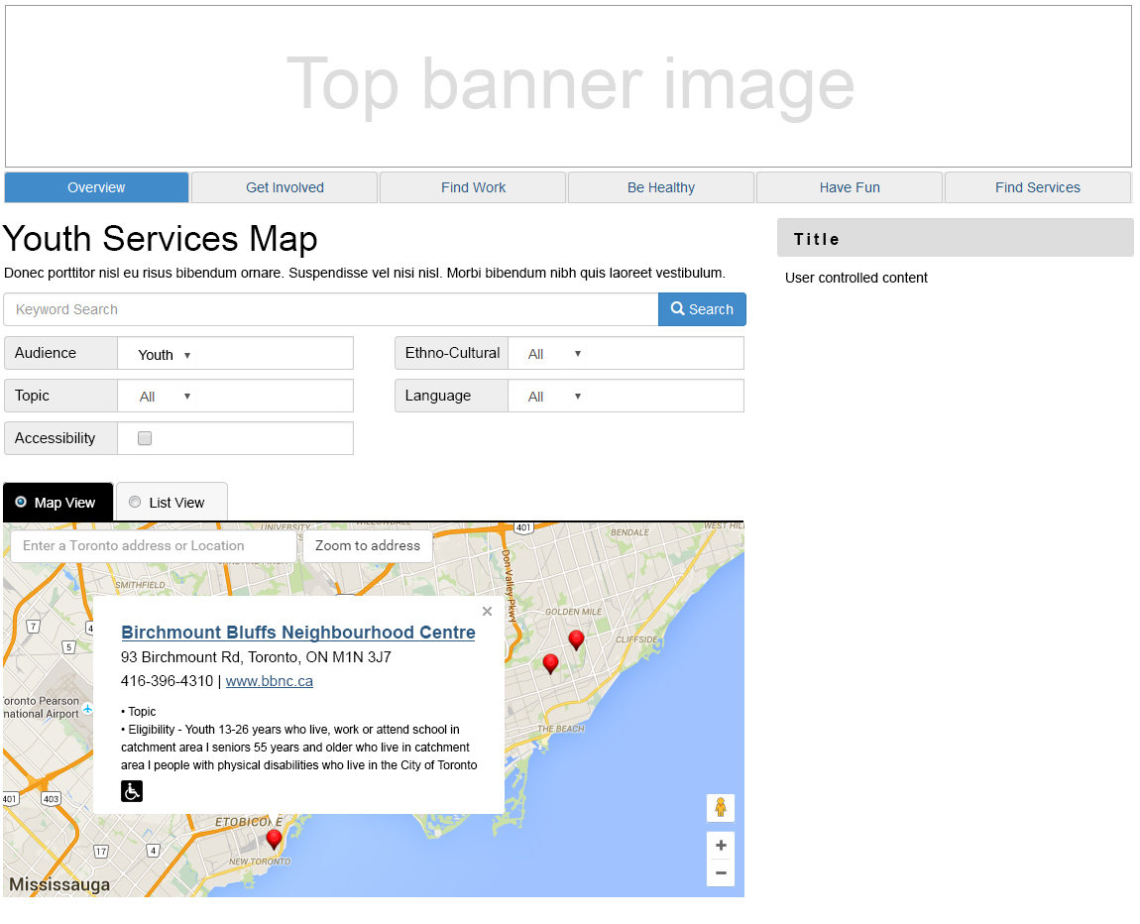

# List

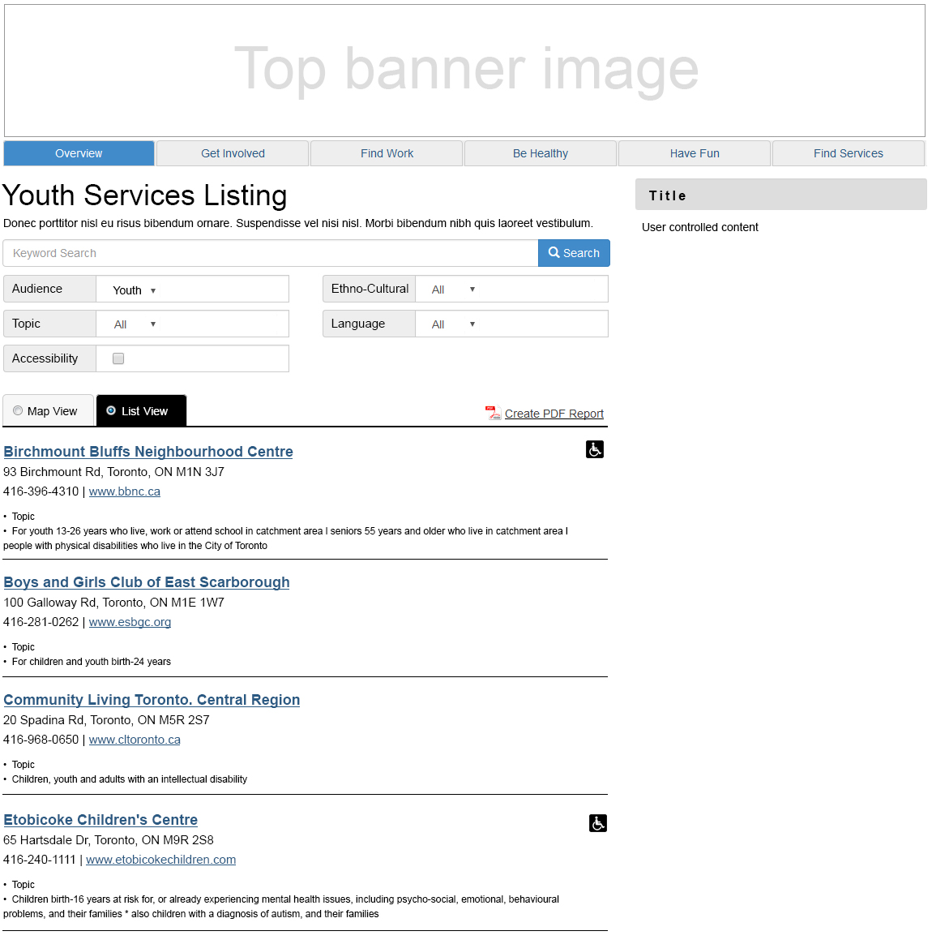

# Details

